**Application for:** Humanitarian project Healthcare facilities “ Verkhnedvinsk Central Regional Hospital «**Health without barriers »** looking for donor .

|  |  |
| --- | --- |
| **1.Name of the project:** | «Health without barriers» » -Organization of free outdoor exercise for older people and people with disabilities on nursing bed care in Bigosovo district hospital, Osvey district hospital by installation elevator for older people and people with disabilities.Лестничный подъмник.jpg |
| **2.Duration of the project:** | 2023 -2026 years. |
| **3.Applicant organization :** | Healthcare facilities «Verkhnedvinsk Central Regional Hospital» |
| **4.Objectives of the project:** | -Organization of free movement of older people and people with disabilities ;  -improving the quality of life of older persons through motor activity, which will lead to better health ;  -Reduction of dependency on medical personal and relatives;  -the ability not to feel isolated from society, the environment;  -Physical and health care, psychological discharge to inhabitants in nursing beds ;  -Access of citizens to domestic services, the environment |
| **5. Tasks of the project :** | -Develop a healthy and sustainable lifestyle ;  - Accessibility to physical activity zones, recreation areas (pergolas ,benches), nature;  -Correcting abnormal or severely impaired body functions;  -Provision of adaptation assistance to persons with disabilities as well as senior citizens;  -Extension of the lives of the disabled and the elderly;  -Striking the line between healthy people and people with disabilities . |
| **6. Task force:** | Older persons and persons with disabilities. Лестничный подъемник.jpg |
| **7.Summary of the project activities:** | For realization of the project it is necessary :  1.4 inclined (flattering) elevators for the movement of persons with reduced mobility and disabled persons in wheelchairs.  2. Production of design and cost documentation for the installation and mounting of lifts.  3. Installation and mounting of lifts along the stairs on a straight tractor inside the public building. |
| **8. Total funding (in United States dollars)** | 25 000 United States dollars |
| Source of funding | Source of funding in United States dollars |
| Fund of contributor | 24 500 United States dollars |
| Co-funding | 500 United States dollars |
| Location of the project (region, district, town) | 9 Partizanskaya Street  Vitebsk region, Verkhnedvinsk district Yanino  211622 |
| Contact person:  Initials, name, post, telephone, fax, e-mail | Krystsina Ramankova  Head physician Healthcare facilities “Verkhnedvinsk Central Regional Hospital”  Telephone-fax: 80215163234  info@vdvinskmed.by |

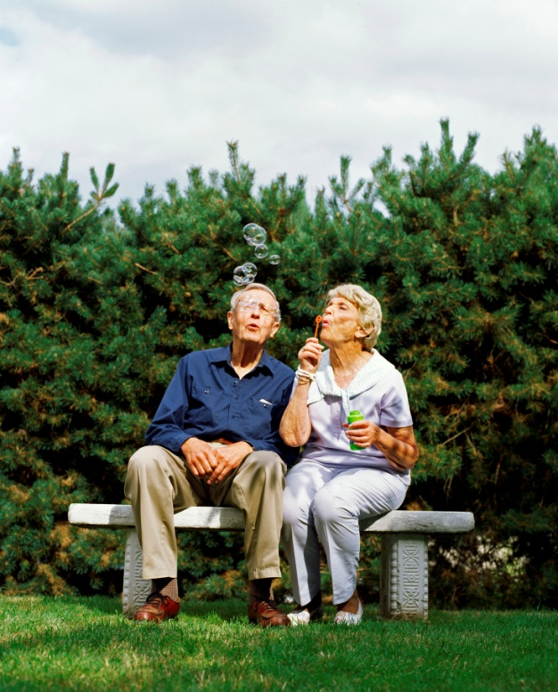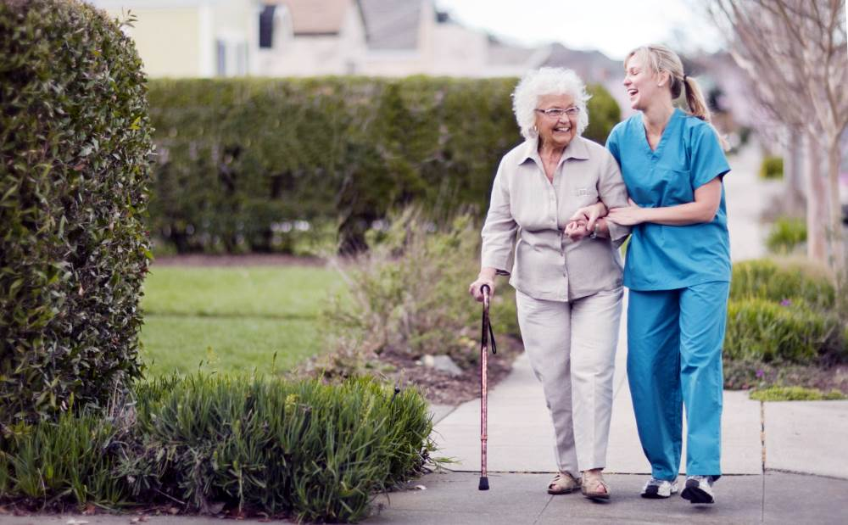

WE WILL SINCERELY APPRECIATE THE COOOPERATION AND ASSOSTANCE OF ALL KIND TO THE ELDERLY PERSONS AND THE PERSONS WITH DISABILLITIES!